create table student(Roll_no varchar(10) NOT NULL,

Name varchar(25) NOT NULL,Department varchar(5),primary key(Roll_no));

insert into student values('561','keerthi','CSE');

insert into student values('547','Vidya','CSE');

insert into student values('5G0','Supriya','CSE');

insert into student values('221','Soniya','EEE');

insert into student values('201','Vyshnavi','EEE');

insert into student values('1207','Sandhya','IT');

insert into student values('461','Vandhana','ECE');

insert into student values('412','Divya','ECE');

insert into student values('12A0','Sonika','IT');

select * from student;

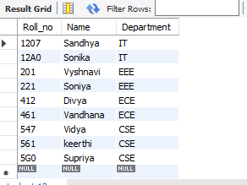

select Roll_no,Department from student;

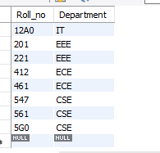

update student set Name='Suakshara' where Roll_no='561';

update student set Name='Rakshitha' where Roll_no='221';

